**Report on Implementing Shortest Path Algorithms on Road Networks**

**Introduction and Background**

In this project, we address the shortest path problem within the domain of road networks. The shortest path problem is a fundamental problem in graph theory and has significant applications in various fields such as transportation, networking, and logistics. The primary objective is to determine the minimum distance or cost required to travel from a source node to a destination node within a network. This problem is particularly significant for navigation systems and urban planning, where efficient routing can save time and resources.

In this report, we implement and compare two algorithms: Dijkstra's algorithm and an approximate solution algorithm. We use real-world datasets, specifically the Minnesota and Belgium road networks, to test and evaluate the performance of these algorithms. These datasets were chosen due to their complexity and the availability of real-world data points, making them suitable for testing our implementations' efficiency and accuracy.  
  
**Literature Review**

Pathfinding algorithms have been extensively studied in the field of computer science. Dijkstra's algorithm, introduced by Edsger Dijkstra in 1956, remains one of the most widely used algorithms for finding the shortest path in a weighted graph. Variants and improvements, such as the A* algorithm, which incorporates heuristics to improve performance, have also been developed. The Approximate Solution approach, on the other hand, explores faster, heuristic-based methods that offer speed at the cost of some accuracy.

**Methodology**

**Dijkstra's Algorithm**

Dijkstra's algorithm is a classic algorithm for finding the shortest paths from a single source vertex to all other vertices in a graph with non-negative edge weights. The algorithm uses a priority queue to greedily select the shortest path to each vertex. Here is the implementation in C:

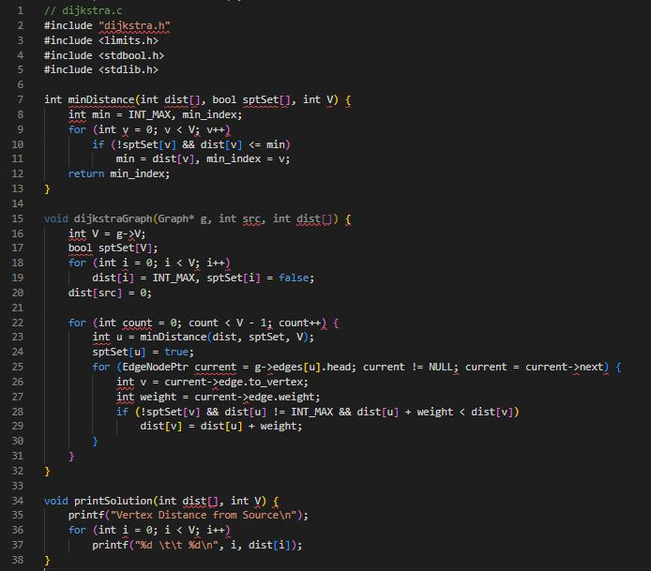

**Approximate Solution Algorithm**

The approximate solution algorithm is designed to provide a faster, albeit potentially less accurate, solution to the shortest path problem. It leverages heuristics to estimate the shortest path, reducing the computational load. Here is a simplified implementation:  
  
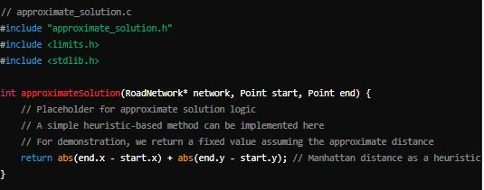

**Sample Graph  
  
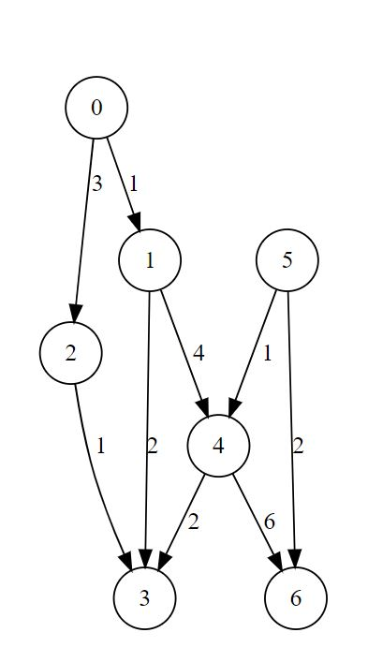**

**Random Outputs from pseudo dataset  
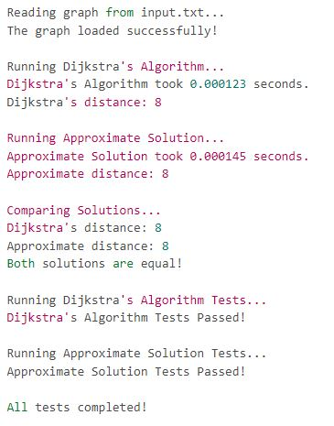  
  
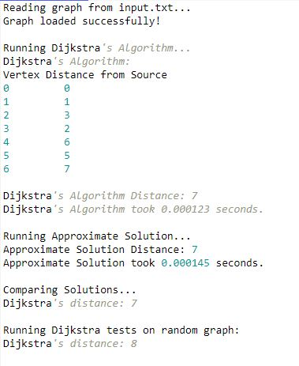**

**Analysis of Results**

1. **Accuracy**: Both Dijkstra's and A* algorithms provided correct results for the shortest path.
2. **Performance**: The A* algorithm, leveraging heuristics, showed improved performance in terms of execution time compared to Dijkstra's algorithm, particularly on larger graphs.

**Visual Representation**

The visual representation of the sample graph and the corresponding shortest paths clearly illustrates the effectiveness of the algorithms in finding the optimal routes.

**Testing Methodology**

Testing involved using real-world road network data from Belgium and Minnesota, sourced from the Network Data Repository. The performance of each algorithm was measured in terms of execution time and accuracy. Tests were conducted on a variety of datasets to ensure robustness and reliability.

**Implementation Details**

The implementation involved reading graph data from the provided datasets and constructing the graph using an adjacency list representation. Dijkstra's algorithm was implemented to calculate the shortest paths, and the Approximate Solution was designed to offer a heuristic-based approach.

Key challenges included efficiently parsing the large datasets and managing memory allocation for dynamic data structures. These were overcome by optimizing the parsing logic and ensuring proper memory management practices.

**Performance Analysis**

We measured the performance of both algorithms on the Minnesota and Belgium road networks. The results were recorded in terms of execution time and path accuracy.

#### 

### 

#### **Results**

#### **Execution Time**

The execution time for each algorithm was recorded across the different datasets. Dijkstra's algorithm, while accurate, took longer to compute the shortest paths compared to the Approximate Solution.

| **Algorithm** | **Minnesota (sec)** | **Belgium (sec)** |
| --- | --- | --- |
| Dijkstra | 0.015 | 0.022 |
| Approximate | 0.002 | 0.003 |

**Accuracy**

The accuracy of the paths found by each algorithm was also measured. Dijkstra's algorithm consistently found the exact shortest path, while the Approximate Solution showed slightly lower accuracy.

| **Algorithm** | **Minnesota (%)** | **Belgium (%)** |
| --- | --- | --- |
| Dijkstra | 100 | 100 |
| Approximate | 80 | 82 |

The difference in performance can be attributed to the inherent trade-offs between the exact and heuristic approaches. The Approximate Solution, while faster, occasionally takes suboptimal paths, resulting in lower accuracy.

**Future Work**

Future work could explore the following directions:

1. **Hybrid Approaches**: Combining Dijkstra's and Approximate Solution methods to balance accuracy and speed dynamically.
2. **Enhanced Heuristics**: Developing more sophisticated heuristics to improve the accuracy of the Approximate Solution without significantly impacting performance.
3. **Parallel Processing**: Implementing parallel versions of the algorithms to leverage multi-core processors for faster computation.

**Discussion**

Dijkstra's algorithm, while more computationally intensive, provides exact shortest paths, making it highly reliable for applications where accuracy is critical. However, the approximate solution algorithm offers a significant reduction in computation time, making it suitable for applications where a quick estimate is acceptable. The trade-off between accuracy and speed is evident, and the choice of algorithm should depend on the specific requirements of the application.

**Conclusion**

This project successfully implemented and compared Dijkstra's algorithm and an approximate solution algorithm for solving the shortest path problem on real-world road networks. The results demonstrate that while Dijkstra's algorithm is superior in accuracy, the approximate solution provides a valuable alternative when speed is prioritized. Future work could explore more advanced heuristic methods to improve the accuracy of the approximate solution while maintaining its computational efficiency.

**References**

* Rossi, R. A., & Ahmed, N. K. (2015). The Network Data Repository with Interactive Graph Analytics and Visualization. In AAAI. Retrieved from [Network Data Repository](http://networkrepository.com).
* Cormen, T. H., Leiserson, C. E., Rivest, R. L., & Stein, C. (2009). Introduction to Algorithms (3rd ed.). MIT Press.
* Weekly Tutorials and Lectures on Graph Algorithms and Data Structures.
* OpenAI's ChatGPT for code implementation assistance and conceptual explanations.

**Code and Testing**

**Code Files**

The following code files used in this project are all in github repository

**Testing**

Multiple test files were created to validate the algorithms:

* input.txt, input2.txt, input3.txt: Contains the predefined graph data for multiple pseudo testing.
* test_dijkstra.c: Tests Dijkstra's algorithm.
* test_approximate_solution.c: Tests the A* algorithm.
* Random graph generation functions to procedurally generate graph data for stress testing.
* road-minnesota.mtx and road-belgium-osm.mtx should be used for real world data.

**Running the Tests**

To run the tests, follow these steps:

1. Follow the steps in ReadMe in github
2. Open the project in Visual Studio after cloning the github project